Applied Microeconomics — Week 5
Taxation: incidence and efficiency — plus Pigouvian taxes and subsidies
_Summary of Lecture 5 (Delfgaauw), Public Economics, with worked examples from Practicum 5. Slide numbers in brackets. Section 7 on Pigouvian taxes and subsidies draws on Lecture 2 and Practicum 2._

The two questions
Every tax is evaluated on the same two criteria as every other policy in the course [3]:
 | Question | Short answer
Incidence | Who actually bears the tax? | Whoever is less elastic — regardless of who pays it to the government
Efficiency | What does it cost beyond the revenue? | The excess burden, caused by the substitution effect

On the distribution side, two ideas of fairness: horizontal equity (equal people pay equal taxes) and vertical equity (those better off pay more).

1. General remarks slides 5–10
- Only people bear taxes. A tax on 'firms' or 'capital' is ultimately paid by owners, workers or customers.
- Unit vs ad valorem. A unit tax (excise) is a fixed amount per unit; an ad valorem tax (VAT) is a percentage of the price.
- Average vs marginal rate. With T = 0.25(Y − 5000) and Y = 25,000: tax = 5,000, average rate 20%, marginal rate 25%.
- Progressivity is measured by the average tax rate. Rising in income: progressive. Falling: regressive. Constant: proportional.
T = a + tI → ATR = a/I + t → dATR/dI = −a/I²
progressive if a < 0, regressive if a > 0 Rosen 14.8: T = −4000 + 0.2I is progressive
Note that progressivity comes entirely from the intercept here: the marginal rate t is constant either way.

2. Incidence slides 11–24

Statutory vs economic incidence
- Statutory incidence: who legally pays the tax to the government (VAT: consumers; Dutch wage tax: partly employers, partly employees).
- Economic incidence: whose welfare actually falls. Through tax shifting via prices, this need not be the party that pays.
The striking result [12]: economic incidence is completely independent of statutory incidence.

How a unit tax works slides 14–17
A unit tax u on producers shifts the supply curve up by exactly u: to supply any quantity, producers now need u more. The result is a wedge between the two prices:
P_{d} = P_{s} + u what consumers pay = what producers keep + tax
Worked example (exercise 5.1): demand P = 10 − ⅔Q, supply P = 1 + ⅓Q, tax t = 3 on producers.
- Before the tax, set demand = supply: 10 − ⅔Q = 1 + ⅓Q gives Q = 9, P = 4.
- Shift supply up by 3: P = 4 + ⅓Q.
- Set equal again: 10 − ⅔Q = 4 + ⅓Q gives Q = 6, consumer price 6.
- Producer price = 6 − 3 = 3. Check on the original supply curve: 1 + ⅓(6) = 3 ✓.
- Burden = price change × new quantity: consumers 2 × 6 = 12, producers 1 × 6 = 6, total = revenue 3 × 6 = 18 ✓.
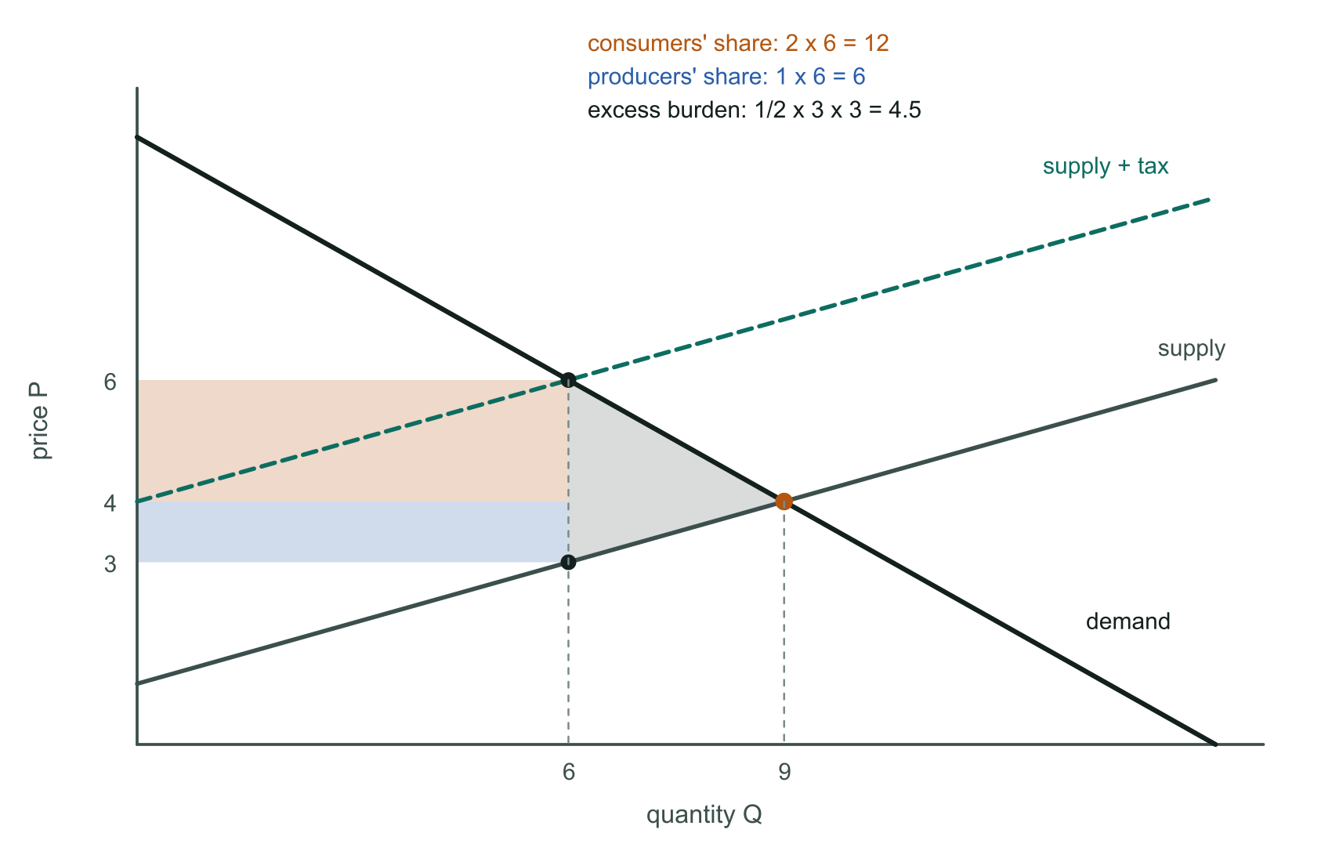
Exercise 5.1. Orange: consumers' share of the revenue. Blue: producers' share. Grey triangle: excess burden.
Who pays doesn't matter [17–18]: put the same tax on consumers and demand shifts down by u instead, giving the identical Q, P_{d} and P_{s} (proved in Rosen 14.6). The same holds for payroll taxes: whether employers or employees pay is irrelevant [23].

What decides the split: elasticities slides 19–22
ε = (dQ/dP) × (P/Q) measured at a point
consumer share of the burden = ε_{s} / (ε_{s} + |ε_{d}|)
How to compute ε when the curve is given as P = f(Q): take dP/dQ and flip it, since dQ/dP = 1/(dP/dQ). For exercise 5.1 at (Q, P) = (9, 4):
 | dP/dQ | dQ/dP | ε = (dQ/dP)(P/Q)
Demand | −2/3 | −3/2 | −1.5 × 4/9 = −2/3
Supply | +1/3 | 3 | 3 × 4/9 = 4/3

Supply is twice as elastic as demand, so consumers bear twice as much: (4/3) / (4/3 + 2/3) = 2/3 ✓, exactly the 12 : 6 split.
Case | Who bears the tax
Perfectly elastic supply [21] | consumers, 100%
Perfectly inelastic supply [22] | producers, 100%
In general | the less elastic side bears more

Intuition [24]: elasticity measures how good your untaxed alternatives are. The better your alternatives, the easier it is to walk away, and the smaller your share. Elasticities are larger in the long run than in the short run, so incidence can shift over time.

3. Excess burden at the market level slides 25–28
Tax revenue is not a loss — it is a transfer to the government. But the total loss of consumer and producer surplus exceeds the revenue. The difference is the excess burden (deadweight loss):
excess burden = total surplus lost − tax revenue
EB = ½ × t × (Q_{E} − Q_{t}) the triangle, for linear curves
Exercise 5.1: EB = ½ × 3 × (9 − 6) = 4.5. Check: consumers lose 15, producers 7.5, total 22.5 = revenue 18 + EB 4.5 ✓.
Why it arises [28]: competitive markets set MRS = MRT = P_{X}/P_{Y}. The tax drives a wedge — consumers react to the price they pay, producers to the price they keep — so MRS ≠ MRT, and the units between Q_{t} and Q_{E}, worth more to consumers than they cost to make, are no longer traded.
- More elastic demand or supply → larger ΔQ for the same tax → larger excess burden.
- Perfectly inelastic either side → ΔQ = 0 → no excess burden (Rosen 15.9, the TV licence).
- Excess burden rises with t²: doubling a tax roughly quadruples the waste (Rosen 15.5: raising a rate from 35% to 44% raises EB by (44/35)² − 1 ≈ 58%).

4. Excess burden at the individual level slides 29–35
A single consumer with fixed income buys cola and beer, and beer is taxed. The key question [31]: before the tax, how much income could we take away to leave the consumer exactly as well off as after the tax? That amount is the equivalent variation (EV).
excess burden = EV − tax revenue
How to find EV [32]: shift the pre-tax budget line down in parallel until it just touches the post-tax indifference curve. The size of the shift is the EV.
Why EV exceeds revenue [34–35]: the price rise has two effects.
- Income effect: you can afford less overall. This part corresponds to the revenue.
- Substitution effect: beer is relatively dearer, so you switch towards untaxed goods. That lowers the tax you pay but moves you away from what you prefer.
The substitution effect is what creates the excess burden. If the substitution effect is zero, EV = revenue and there is no excess burden.

Worked example slide 39
U = √C + 4√B, income 90, P_{C} = 1, P_{B} = 2, a tax of 2 on B, supply of B perfectly elastic (consumers bear all of it).
- Demand rule. MRS = (2/√B)/(1/(2√C)) = 4√C/√B = P_{B}, so C = (P_{B}²/16) × B.
- Before the tax (P_{B} = 2): C = B/4 and B/4 + 2B = 90, so B = 40, C = 10, U₀ = √10 + 4√40 = 28.46.
- After the tax (P_{B} = 4): C = B and 5B = 90, so B = 18, C = 18, U₁ = 5√18 = 21.21. Revenue = 2 × 18 = 36.
- EV. At pre-tax prices, income M′ buys B = 4M′/9 and C = M′/9, giving U = 3√M′. Setting 3√M′ = 21.21 gives M′ = 50, so EV = 90 − 50 = 40.
- Excess burden = 40 − 36 = 4.
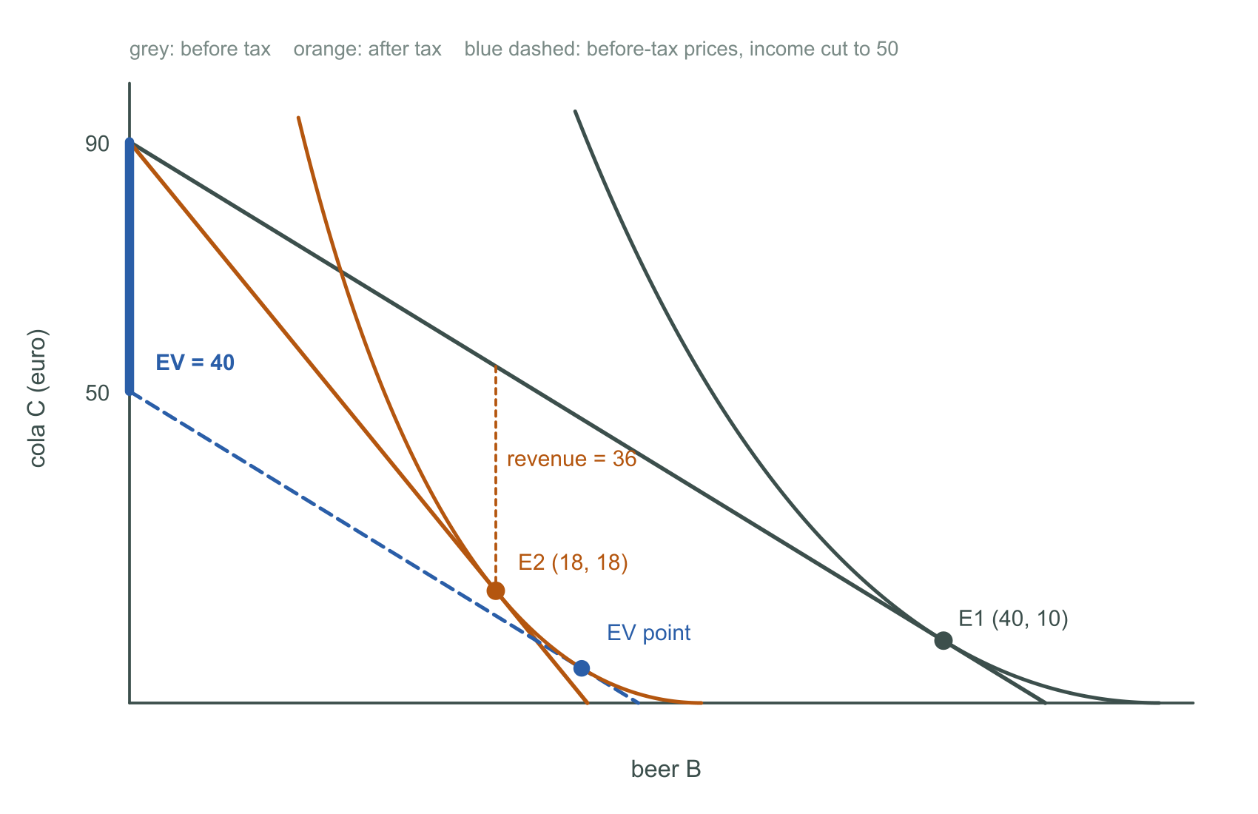
The tax costs the consumer the equivalent of 40 in income, but raises only 36. The gap of 4 is the excess burden.
Move | Beer | Effect
E1 (B = 40) → EV point (B = 22.2) | −17.8 | income effect, at pre-tax prices
EV point (B = 22.2) → E2 (B = 18) | −4.2 | substitution effect — the source of the excess burden

Practicum 5.2 (Betty) makes the same point in its sharpest form: with Cobb-Douglas utility her hours don't change at all under a 20% income tax, because income and substitution effects cancel. Yet the excess burden is 525.63 − 480 = 45.63, because the substitution effect still exists. No change in behaviour does not mean no excess burden.

5. Lump-sum taxes slides 36–38
A lump-sum tax is a tax without excess burden. Three equivalent definitions: it does not distort behaviour; its substitution effect is zero; nothing you can do changes what you owe.
- An income tax is not lump-sum [37]: the budget constraint changes from Y = (T − L)w to Y = (T − L)(1 − t)w, so leisure becomes relatively cheaper.
- A head tax is lump-sum [38]: you pay a fixed amount for having a head. The main reason it isn't used is fairness — rich and poor pay the same, so it is extremely regressive.
This is the same reason the second fundamental theorem's lump-sum redistribution stays theoretical (week 4).

6. Rosen and practicum results worth remembering
Exercise | Result
Rosen 14.3 | Constant cost, linear demand: a unit tax u raises price by u under competition but only u/2 under monopoly
Rosen 14.5 | Liquor: P rises 10 → 10.60, producers keep 9.60; consumers bear 60% because ε_s = 1.0 vs |ε_d| = 0.67
Rosen 15.11 | A tax of 6 on corporate capital moves 2 units to the less productive sector; EB = ½ × 6 × 2 = 6
Rosen 15.12 | Liquor EB = ½ × 12,000 × $1 = $6,000; smaller if drinking has an external cost
Practicum 5.3 | Harry's budget line rotates through his old choice: a pure substitution effect, so he works less
Practicum 5.4 | Raising 800 for a park worth 1000 costs 800 + 400 excess burden = 1200: don't build it

7. Pigouvian taxes and subsidies Lecture 2, slides 25–31; Practicum 2
Almost every tax creates an excess burden because it distorts a market that was working. A Pigouvian tax or subsidy is the exception: it is aimed at a market that is already distorted by an externality, and it removes a distortion rather than creating one.
The idea: an externality exists because one party doesn't pay (or isn't paid) for a side-effect. A Pigouvian instrument puts a price on the side-effect, so the decision-maker internalises it and chooses the socially efficient quantity by themselves.

The rule
Externality | Instrument | Set it equal to
Negative (pollution) | Pigouvian tax per unit of output | marginal damage MD at the efficient Q*
Positive (education, R&D) | Pigouvian subsidy per unit | marginal external benefit MEB at the efficient Q*
Negative, alternative | subsidy per unit of reduction below the market level | MD at the efficient Q*

Always at the EFFICIENT quantity Q*, never at the market quantity. When MD changes with Q, using MD at the market quantity sets the wrong tax.

How to calculate a Pigouvian tax: step by step
- Write down MPB (private benefit), MPC (private cost) and MD (marginal damage). If you are given total damage D, differentiate it: MD = dD/dQ.
- Build social cost: MSC = MPC + MD. Social benefit is MSB = MPB (no external benefit).
- Find the market outcome: MPB = MPC gives Q_{P}.
- Find the efficient outcome: MSB = MSC, i.e. MPB = MPC + MD, gives Q*.
- Tax = MD evaluated at Q*.
- Check: the firm now sets MPB = MPC + tax. That must give Q*.

Worked example 1: paint (Practicum 2.2)
MPB = 10 (fixed price), cost 10 + Q², emissions W = ¼Q, damage D = 4W².
MPC = d(10 + Q²)/dQ = 2Q
D = 4(¼Q)² = ¼Q² → MD = ½Q
MSC = 2Q + ½Q = 2.5Q
market: 10 = 2Q → Q_{P} = 5
efficient: 10 = 2.5Q → Q* = 4
tax = MD(4) = ½ × 4 = 2
check: 10 = 2Q + 2 → Q = 4 ✓
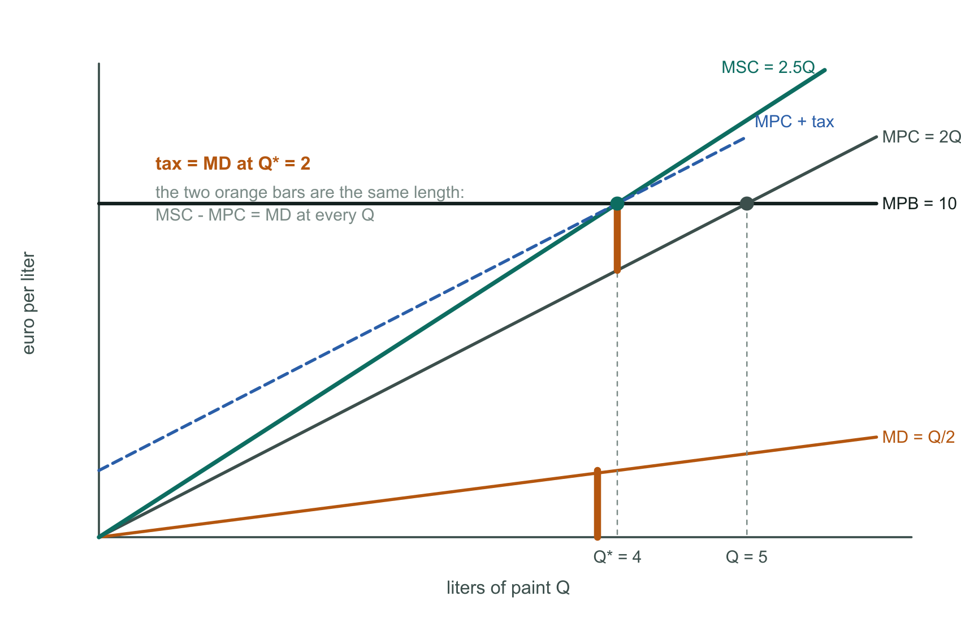
The tax shifts MPC up by MD(Q*) = 2, so the new private cost curve passes through the efficient point.
Revenue = 2 × 4 = 8. Welfare gain = the triangle removed between MSC and MPB over Q = 4 to 5: ½ × 1 × 2.5 = 1.25 (profit falls 15 → 14, damage falls 6.25 → 4, net +1.25).
Why not use MD at the market quantity? MD(5) = 2.5, and 10 = 2Q + 2.5 gives Q = 3.75 — too little. Because damage rises with output here, the right tax is the damage of the last unit you WANT produced.

Worked example 2: constant damage (Rosen 5.12)
MPB = 10 − X, MPC = 5, external cost 2 per unit.
market: 10 − X = 5 → X = 5
efficient: 10 − X = 5 + 2 → X* = 3
tax = MD = 2 constant, so it's 2 at every X
revenue = 2 × 3 = 6; welfare gain = ½ × (5 − 3) × 2 = 2

How to calculate a Pigouvian subsidy (positive externality)
- Write down MPB, MEB (marginal external benefit) and MC.
- Build social benefit: MSB = MPB + MEB.
- Market outcome: MPB = MC gives the (too low) private quantity.
- Efficient outcome: MSB = MC gives Q*.
- Subsidy = MEB evaluated at Q*.
- Check: with the subsidy, people face price MC − s; MPB = MC − s must give Q*.
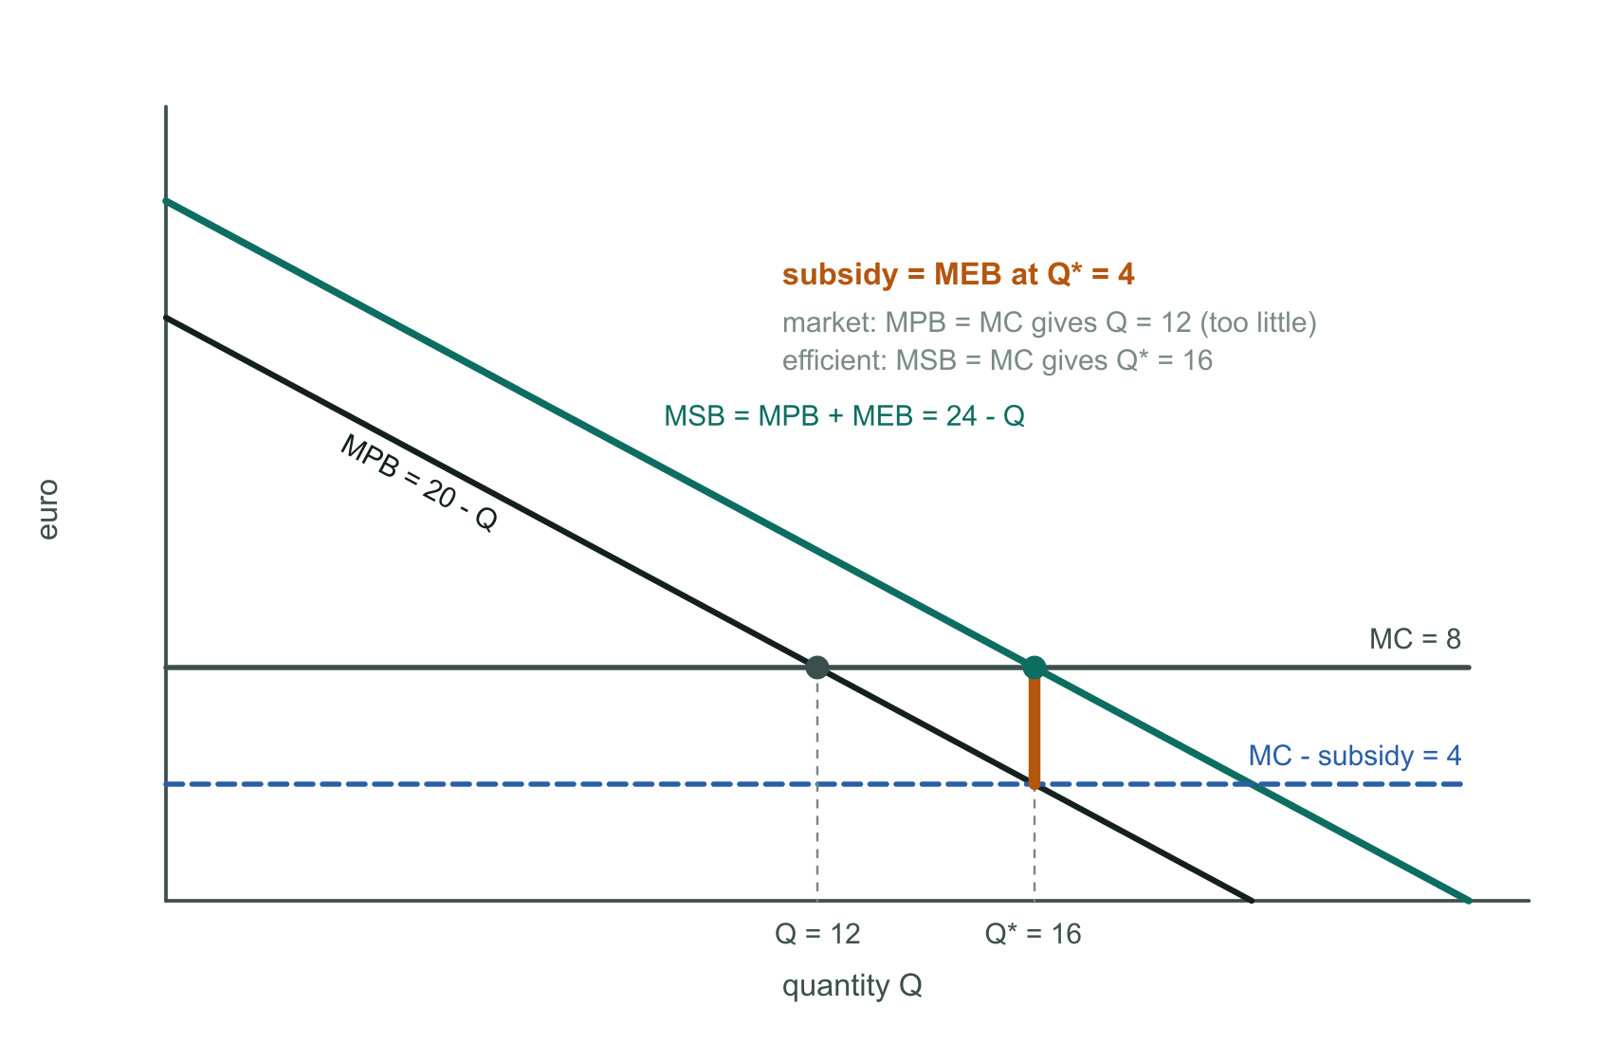
Illustrative numbers. The subsidy lowers the price people face by MEB(Q*) = 4, moving the private choice from 12 up to the efficient 16.

Worked example 3: university education (Practicum 2.5)
Demand (MPB): P = 100 − 2q. MEB = 25 − ½q. Marginal cost 20.
market: 100 − 2q = 20 → q = 40
MSB = (100 − 2q) + (25 − ½q) = 125 − 2.5q
efficient: 125 − 2.5q = 20 → q* = 42
subsidy = MEB(42) = 25 − 21 = 4
check: 100 − 2q = 20 − 4 = 16 → q = 42 ✓
total subsidy spending = 4 × 42 = 168
Free education (a subsidy of 20) overshoots: 100 − 2q = 0 gives q = 50 > 42, so students past q* receive education costing more than its total social value. A subsidy set above MEB creates its own excess burden.

Pigouvian subsidy for reducing a negative externality Lecture 2, slide 29
Instead of taxing each unit produced, the government can pay the polluter MD(Q*) for every unit it produces below the market level Q_{P}. Producing one more unit now also costs the polluter the subsidy it gives up, so its effective marginal cost is again MPC + MD(Q*), and it chooses Q* — exactly as under the tax.
subsidy bill = MD(Q*) × (Q_{P} − Q*) paint: 2 × (5 − 4) = 2 paid to the firm

Tax vs subsidy, and the connection to this week
 | Pigouvian tax | Pigouvian subsidy
Output | Q* | Q* (the same)
Money flows | polluter pays government | government pays polluter
Main difference | distribution | distribution
Information needed | MD at Q* | MD at Q*, plus a baseline Q_P

- No excess burden: an ordinary tax distorts a working market; a correctly set Pigouvian tax corrects a broken one, so it removes a deadweight loss (paint: +1.25) while also raising revenue (8). This is the 'double dividend' idea, and why Rosen 15.12(b) finds a smaller excess burden when drinking has an external cost.
- Coase comparison: private bargaining reaches the same Q* when transaction costs are low; Pigouvian instruments are for when they aren't.
- Main practical problem: the government must know MD (or MEB) at Q*, which is hard to measure — leaving room for government failure (Lecture 2, slide 30).

Formula sheet
Concept | Formula | Note
Price wedge | P_d = P_s + t | any unit tax
Elasticity | ε = (dQ/dP)(P/Q) | flip dP/dQ if needed
Consumer share | ε_s / (ε_s + |ε_d|) | incidence
Burden | ΔP × Q_new | each side
Excess burden (market) | ½ × t × ΔQ | linear curves
Excess burden (individual) | EV − revenue | EV via shifted budget line
Average tax rate | ATR = T / I | progressivity
Social cost | MSC = MPC + MD | negative externality
Social benefit | MSB = MPB + MEB | positive externality
Pigouvian tax | t = MD(Q*) | at the efficient Q
Pigouvian subsidy | s = MEB(Q*) | at the efficient Q

Exam checklist
- Solve before-tax and after-tax equilibria: set demand = supply, then shift supply up by t and repeat.
- Always check that P_{d} − P_{s} = t and that each price sits on its own original curve.
- Compute each side's burden as price change × new quantity; the two must sum to the revenue.
- Link the split to elasticities, and explain why: better alternatives mean a smaller share.
- Excess burden = surplus lost − revenue. At the market level it's the triangle; at the individual level it's EV − revenue.
- Excess burden comes from the SUBSTITUTION effect — it can exist even if behaviour doesn't visibly change.
- Know why an income tax isn't lump-sum, and why a head tax is lump-sum but not used.
- Pigouvian tax = MD at Q*, subsidy = MEB at Q* — not at the market quantity. Always check the instrument delivers Q*.

